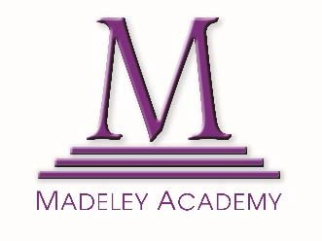

**Contextual Statement for UCAS 2026 Applications**

Madeley Academy is an average-sized community school with an oversubscribed Sixth Form. Half of Sixth Form students join from other local schools. Located in a socially deprived area of Telford, the proportion of students eligible for pupil premium and the 16 to 19 bursary fund is nearly double the national average. The academy is in the highest national quintile for Free School Meals, social deprivation, and SEND, and supports a significantly above-average number of children in care. 38% of the student body is from BAME backgrounds.

Despite these challenges, Sixth Form outcomes are in the top 5% nationally for both academic and vocational courses. Over the past 10 years, all students wishing to attend university have done so, with up to 30% securing places at prestigious institutions, well above national averages. Notably, 70% are first-generation university applicants, reflecting the school’s commitment to raising aspirations.

In Year 12, most students follow a four-subject programme, combining A Levels and Level 3 BTECs, and sit AS-level or equivalent exams to benchmark progress. In Year 13, 60% continue all four subjects, while others drop to three to focus learning or take on work placements.

Course choice is shaped by whole school timetable blocks, which can limit availability of subjects like Further Maths, Economics, Languages, and Computer Science. Students are formally assessed three times a year through class tests, mock exams, and AS results. UCAS predictions, finalised in October of Year 13, are based on robust data, including DfE prediction tools, ensuring students make informed and realistic higher education choices.

